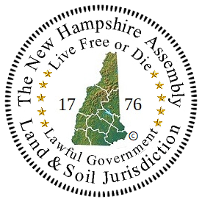

A Letter of Intent to the New Hampshire Assembly

I, _______________________________________________________________,
A living man/woman wish to express my desire and my intent to become a member of the New Hampshire Assembly.

As of this _____ day of ______, 202___, I have not yet corrected my political status. I am in process of/I have not yet started the political status correction paperwork.

I agree to live in peace and honor under the Public Law. Once I have completed the paperwork, I understand that I will need to record and publish the paperwork. To become a member of The New Hampshire General Assembly I will need to send a copy of my paperwork to the state coordinator to be put on the public record.

Autographed and Sealed

By: ______________________________________________________________
Please mail this original autographed Letter of Intent to:
New Hampshire General Assembly
c/o P. O. Box 436
Weare, New Hampshire [03281]
Please notify the coordinator when you do so.
Date: __________________________

Email: __________________________

Phone: _________________________

